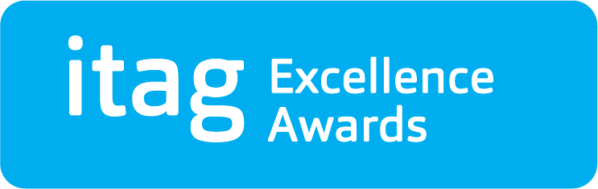 | Award Category  Best Application of AI

Nominee Details
First Name
Surname
Company
Job Title

Nominated By
First Name
Surname
Company
Job Title
Email
Phone No

Criteria for this Award
This itag Excellence award for Best Application of AI recognises a company that has demonstrated exceptional innovation and impact in harnessing artificial intelligence technology to drive advancements in their industry. This award celebrates organisations that have successfully leveraged AI to improve operations, drive business growth, and deliver unparalleled value to customers. The recipient of this award exemplifies excellence in utilising AI to achieve tangible and measurable results, setting a new standard for industry innovation and success.
We will require a minimum of 3 nominees to move forward with shortlisting.
Criteria:
- Quality of Application
- Improvements to operations
- Business Growth as a result of AI application
- Complexity
- Impact

Background Information
Please provide background details of significant achievements, contributions or performances that qualify the nominee for consideration, according to the criteria for this award. (Max 750 words).
The panel of judges place a strong emphasis on the detail provided herein. As such, the detail provided should be accurate, verifiable, specific and concise.

> Add text here…

Summary Information
Please provide a short summary of the above information. (Max 110 words). This text will be used in a booklet for the Awards Ceremony. This paragraph must be in text format (no bullet points).
Please be aware that this information will be reproduced exactly as provided.

> Add text here…

Terms & Conditions
- itag is a non-profit technology association, our mission to develop and support technology innovation along the AtlanTec Gateway.
- All nominations are evaluated by a judging panel.
- Judge’s decision is final.
- The summary nomination provided on this form will be the basis for PR purposes and may appear on the itag website - www.itag.ie
- I confirm that the details given in this nomination form are correct. I agree to itag making enquiries concerning this nomination.

